- Dané sú komplexné čísla a = 1+2i , b = 2 – i. Určite a + b, a – b, a.b, a / b, |a|

Riešenie:
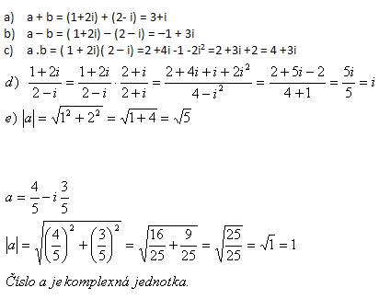

- a = 4 – 3i b = 2 + i
- a = -2 + 3i b = 2 – 5i
- a = 5 – 3i b = -4 -2i
- a = -2i b = - 7 – i

- a = -2 -2i
- a = 1+i
- $$a=−\frac{3}{5}−\frac{4}{5}i$$

- Vypočítajte:
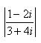

Riešenie:
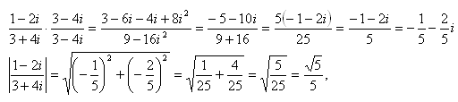

- $$\left|\frac{3−2i}{5−4i}\right|$$
- $$\left|\frac{−2−3i}{5−4i}\right|$$
- $$\left|\frac{−4+3i}{−5i}\right|$$
- $$\left|\frac{−6+i}{3−8i}\right|$$

  - Vypočítajte:
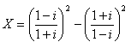

Riešenie:
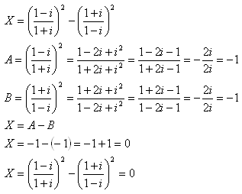
- $$X={\left(\frac{2−3i}{1−5i}\right)}^{2}+{\left(\frac{3−2i}{−3i}\right)}^{2}$$
- $$X={\left(\frac{4−5i}{−3−2i}\right)}^{2}−{\left(\frac{2−7i}{5+4i}\right)}^{2}$$
- $$X={\left(\frac{2−9i}{4−i}\right)}^{2}−{\left(\frac{5+4i}{4−3i}\right)}^{2}$$

